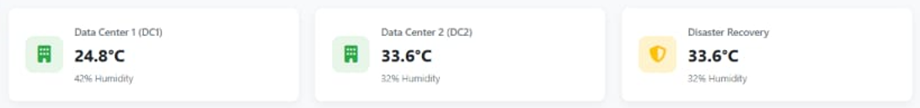**DATA CENTER DETAILS**

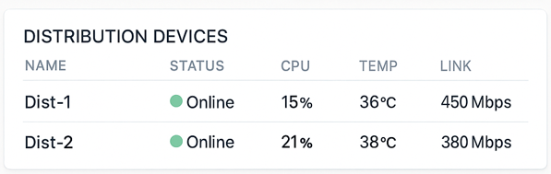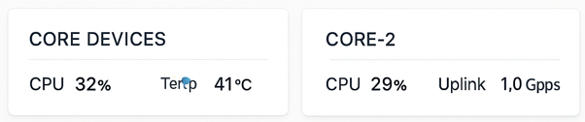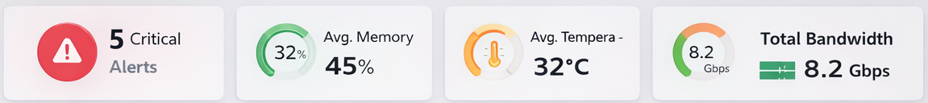**CORE & DISTRIBUTION SWITCH DETAILS**

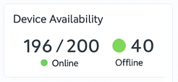**ACCESS SWITCHES STATUS**

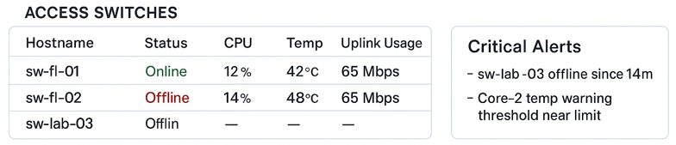

**SWITCH INTERFACE UTILIZATION**

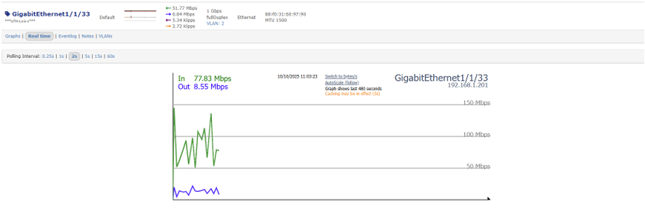

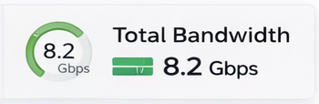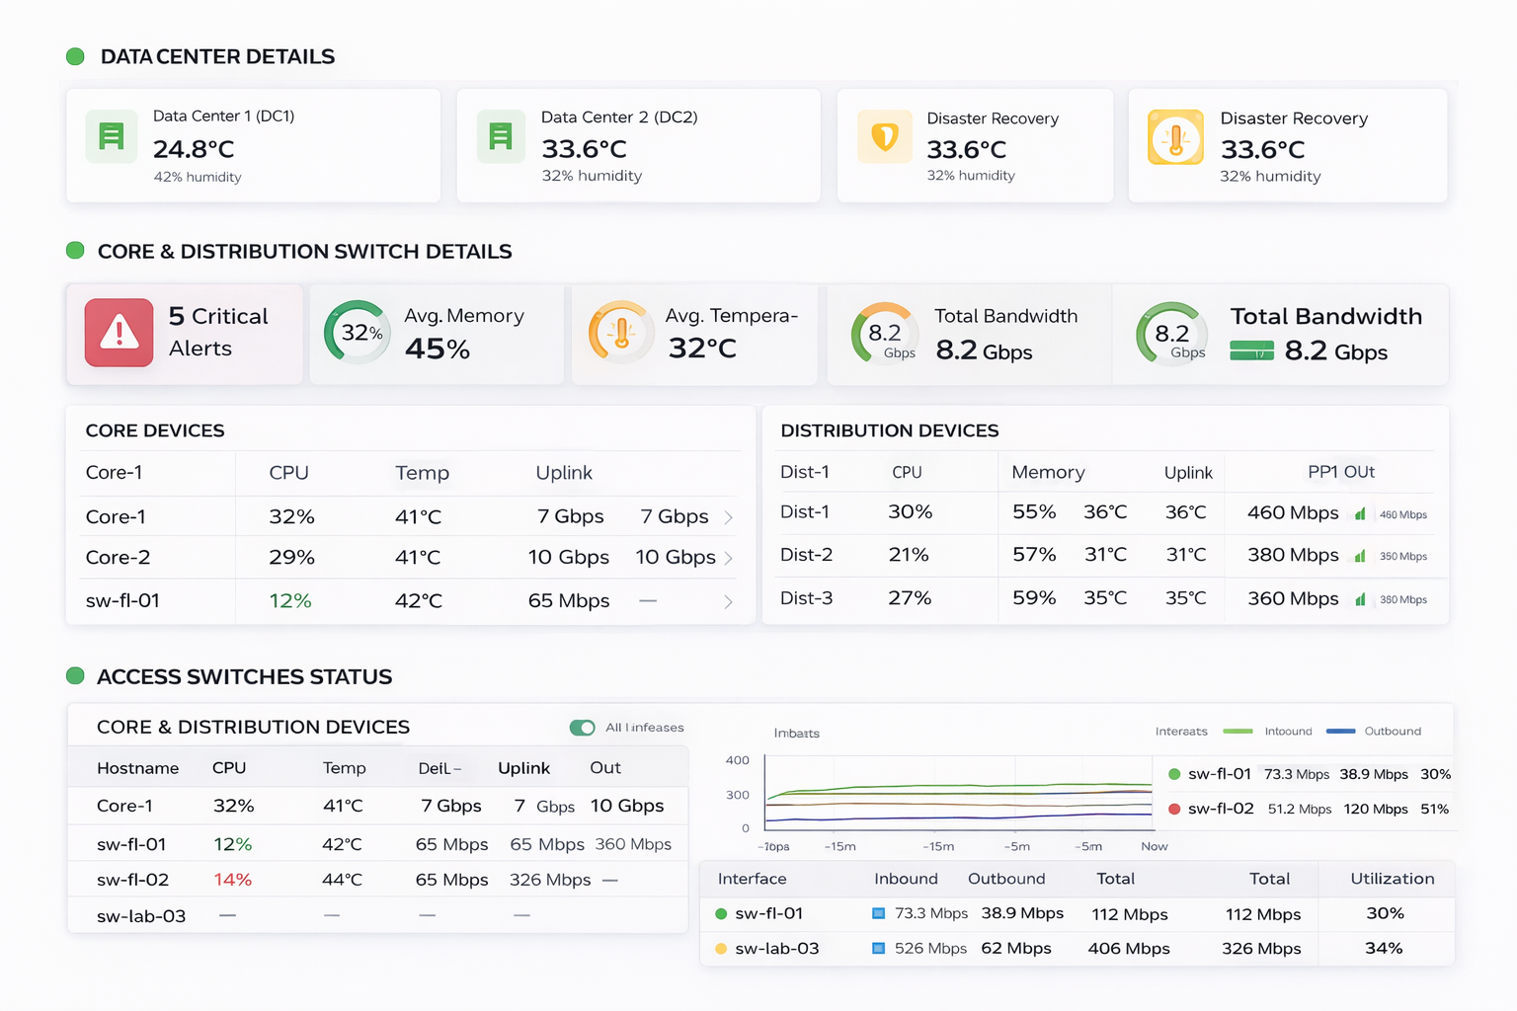( ChatGPT file)

**ISP MONITORING**

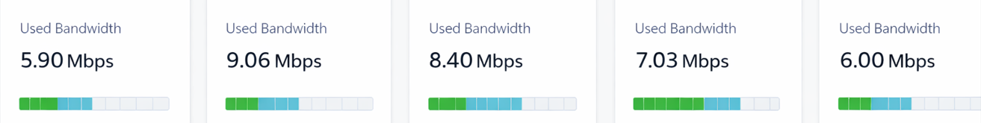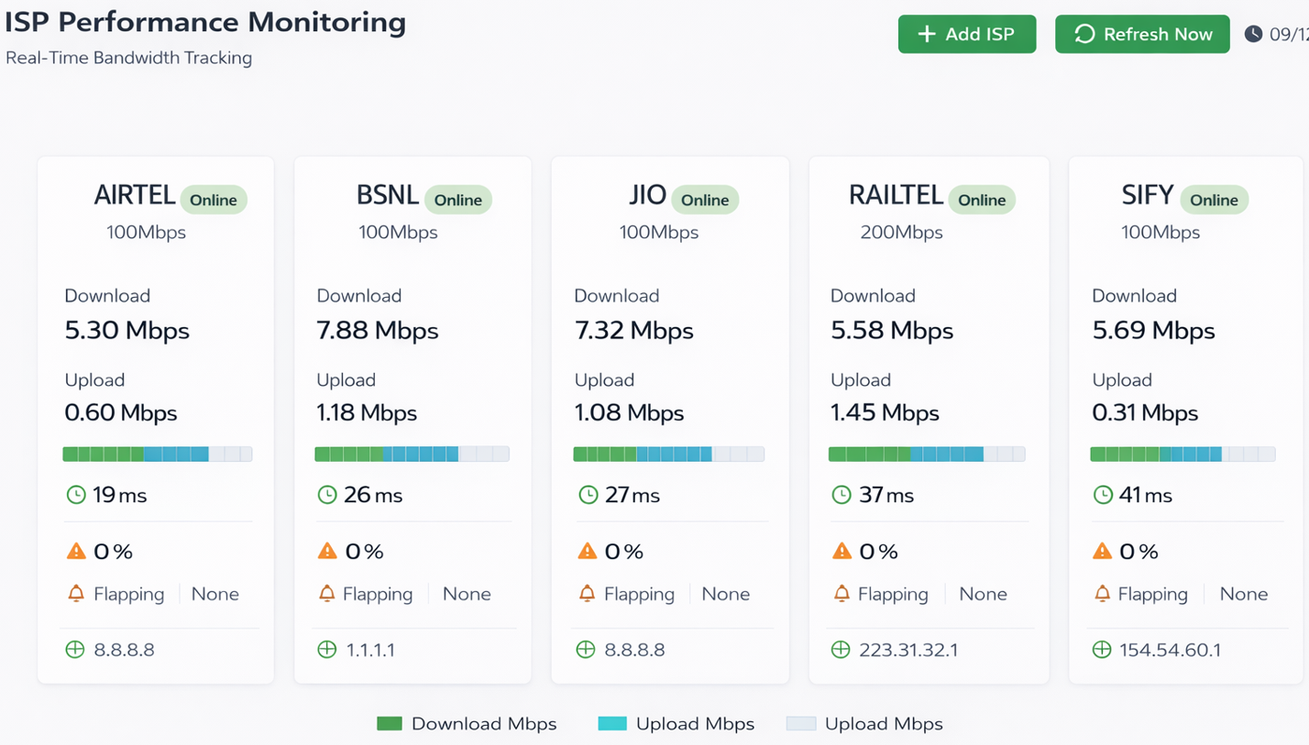

**Add:-**

|  |  |
| --- | --- |
| **Maxi Bandwidth: -** AIRTEL- 100Mbps | **Used Bandwidth: -** 5.90 Mbps |
| **Maxi Bandwidth: -** BSNL- 100Mbps | **Used Bandwidth: -** 9.06 Mbps |
| **Maxi Bandwidth: -** JIO- 100Mbps | **Used Bandwidth: -** 8.40 Mbps |
| **Maxi Bandwidth: -** RAILTEL- 200Mbps | **Used Bandwidth: -** 7.03 Mbps |
| **Maxi Bandwidth: -** SIFY- 100Mbps | **Used Bandwidth: -** 6.00 Mbps |

* Link Latency, packet drops, flapping, critical alerts

**PORT MONITORING**

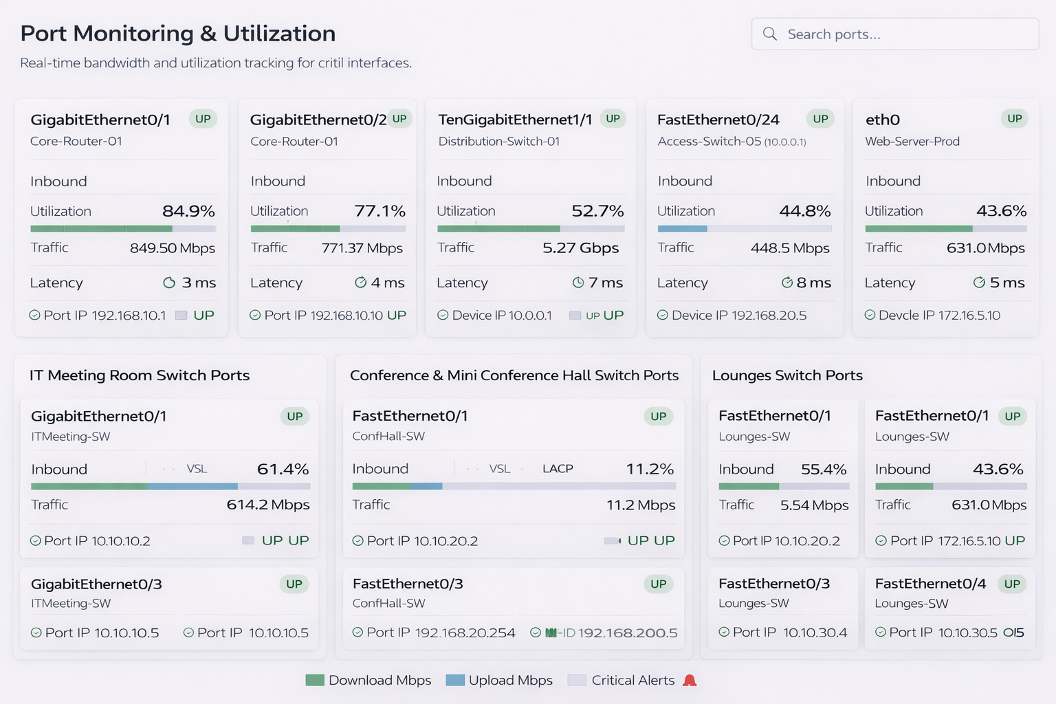

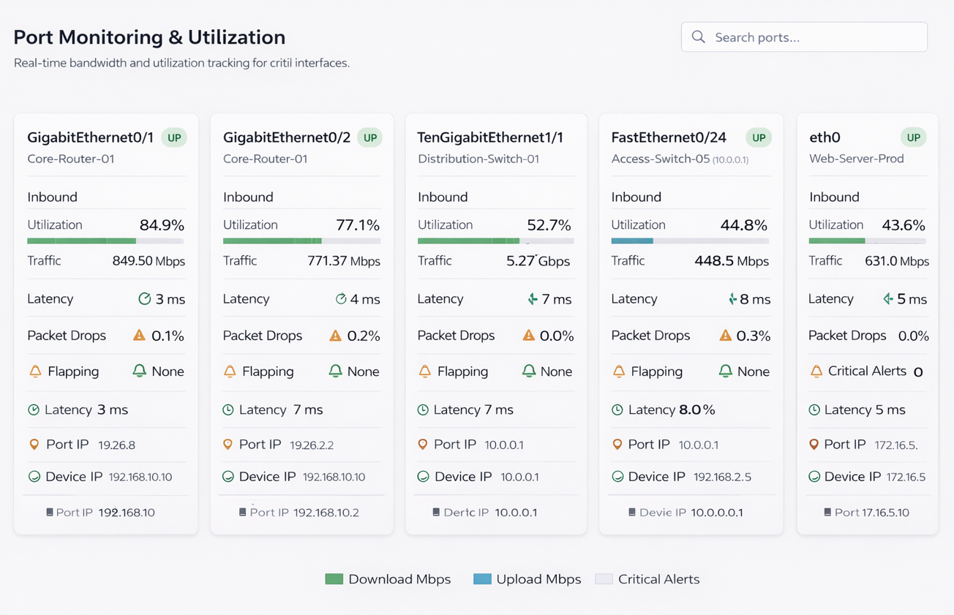

Add: - IT Meeting Room switch Ports, Conference & Mini Conference Hall switch ports & Lounges